Joseph Roper

Salford City College | [Company address]

BTEC National 90 Credit Diploma in Creative Media Production

Unit 72: Computer Games Design

Unit 72 – Task 2

# Game Ideas

## Brief Introduction

### Game Idea 1

The idea for this game is to be a space exploration game where you are sent on a mission by your planet to find new materials, life and an inhabitable planet as yours is dying. In the game you find that there is other life in space however it isn't friendly so you have to defend yourself and your ship while still completing your mission.

### Game Idea 2

The idea for this game is a single player football game where you form a team and compete against other teams to reach the top and be named the best at the sport. This game will be less story driven and will focus more on the interesting game mechanics such as how the pitch you play on will affect the game for example if the pitch is made of ice the footballers will slip and slide while playing.

### Game Idea 3

In the game you play as a child who was separated from his parents as you are left in a shanty town to survive on your own. The child soon becomes wanted for stealing food from market stalls making you wanted by the guards as you climb and crawl through the map being chased while you try to find your parents. The genre of the game will be a puzzle platformer therefore the game will revolve around solving puzzles to unlock the new areas of the game while traversing over the dangerous in-game architecture. A main aspect of the game is also how you would avoid the guards by finding new with your small stature.

## Terrain

### Game Idea 1

he terrain for space exploration game will mainly be empty space. However, on occasion the player will come across an asteroid field providing a challenge for the player to traverse around the space rocks.

### Game Idea 2

The terrain for the football game will be the football pitch which in the first level will be a normal grass pitch with jumpers as the goalpost, then a schoolyard with gravel for the ground meaning that if the player falls they will take longer to get up as it hurts a lot more falling on gravel than grass. Another terrain could be an ice pitch which will make the player slip and slide a lot throughout the match.

### Game Idea 3

The terrain for the platformer game at the start will be a populated desert filled with rubbish and dangerous homes made with scrap metal and plastic. This will mean that the player will have to try and stay in the shade as if they stand in the sun too long they will faint and have to restart from the last checkpoint. Then later on in the game the player will visit a big city changing the terrain to hot tarmac meaning the player will have to find or purchase shoes to be able to walk on the terrain.

## Architecture

### Game Idea 1

The architecture for the space exploration game will be the futuristic spaceships with metal tiles along the walls, ceiling and floor. The player will also be able to find other spaceships which could be damaged changing the architecture of the spaceship to be in tatters with debris falling around the player.

### Game Idea 2

The main architecture for the football game will be the goalposts on the football pitch. therefore, for the first level the goalposts and two jumpers which can be moved to widen the goal. Then later on the player will compete in a football pitch with an actual goalpost. Another form of architecture could be the stadium itself for example in the final levels of the game you will play in a massive football stadium. There will also be bonus levels where you play near a volcano so the goal posts will look like the Stone-henge.

### Game Idea 3

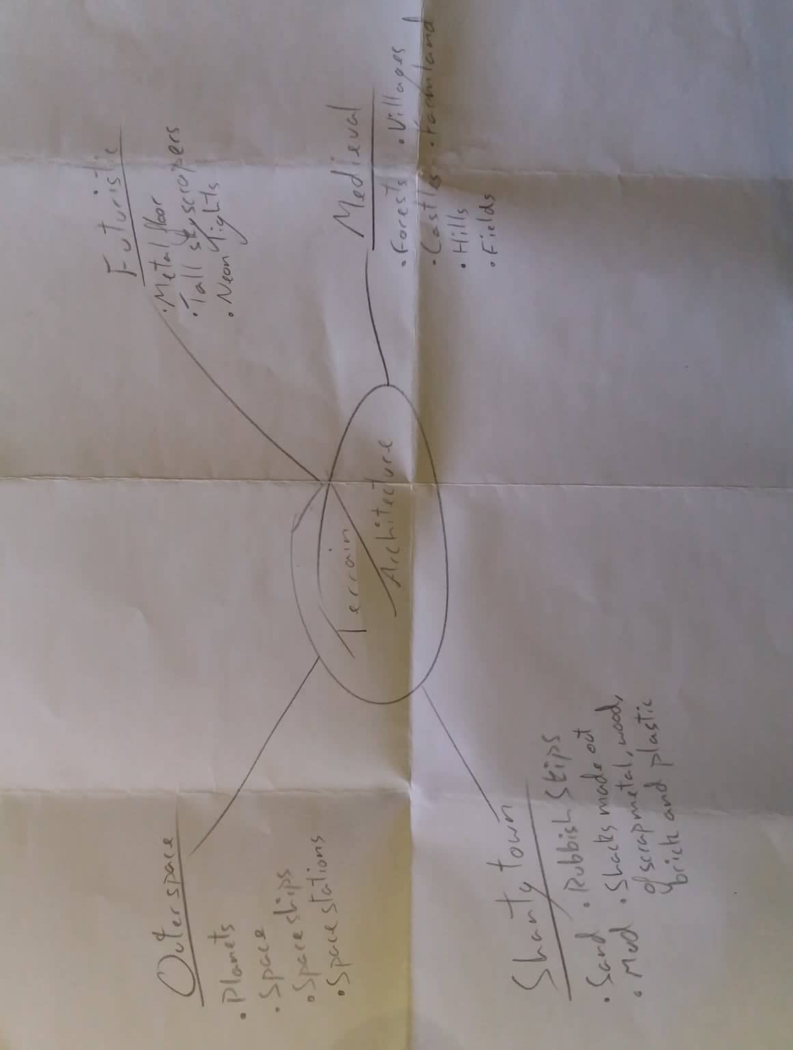The main architecture for the platformer game will be the shanty town that the player spends most of the game traversing through. It will be filled with scaffolding that the player can climb on and houses made out of plastic, wood, bricks and scrap metal towering up throughout the map sort of like the stacks in ready player one. Later on, in the game the player will travel to a massive city compared to the shanty town with skyscrapers, football pitches and a massive white brick church.

## Objects

### Game Idea 1

Objects that would be available in a space exploration game would be spacesuits that the player could equip giving them access to outside the ship into space. Another object for the game could be a hi-tech computer which the player could make daily logs on. One last object could be the spaceship itself that the player could pilot and fly through the galaxy.

### Game Idea 2

Objects that would be available in a football game could be trees which would be placed around the pitch for scenery making the game look good. Another object could be the goal post which will be represented by two jumpers, the player will be able to move these objects to make the goal bigger or smaller. One last object could be the ball itself which the player could change the properties of to say make the ball heavier so it doesn't move as much.

### Game Idea 3

Objects that would be in a shanty town platformer could be wooden boxes that the player can jump on, sticks and rocks that the player can pick up to fight enemies with. One last object could be a sword or more specifically a scimitar which is an exotic weapon which will be held by the guards.

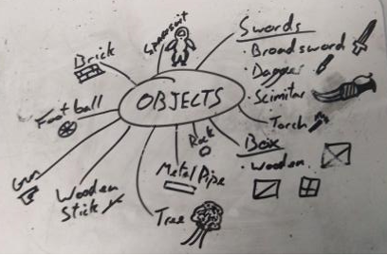

## Characters & NPC’s

### Game Idea 1

the e space exploration game will have you as the only playable character a space explorer that you get to create yourself. The NPC’s will be other space explorers that you meet and fight across your journey which I will create with the character builder used for the player.

### Game Idea 2

The football game will be one player in the story mode. The player will be able to customize their character and will have the option to change the colour of the characters shorts and top. The skin colour will be able to be changed as well as the hair its style and the characters facial expression. The NPC’s in the game will be the players team which will wear the same colours as the player. The other NPC’s will be the players opposing team which will be created by myself using the in-game character builder.

### Game Idea 3

The platformer game will be single player and focus heavily on story therefore the playable character won't be customizable. The playable character will be a boy who was separated from his parents and you have to traverse across the map to find them again. The main NPC’S will be enemies such as the head guard who is trying to get you locked up for stealing from a market stall. Other NPC’s will be low tear crooks that are trying to capture you for the bounty on your head. All of these characters will have set designs made by myself.

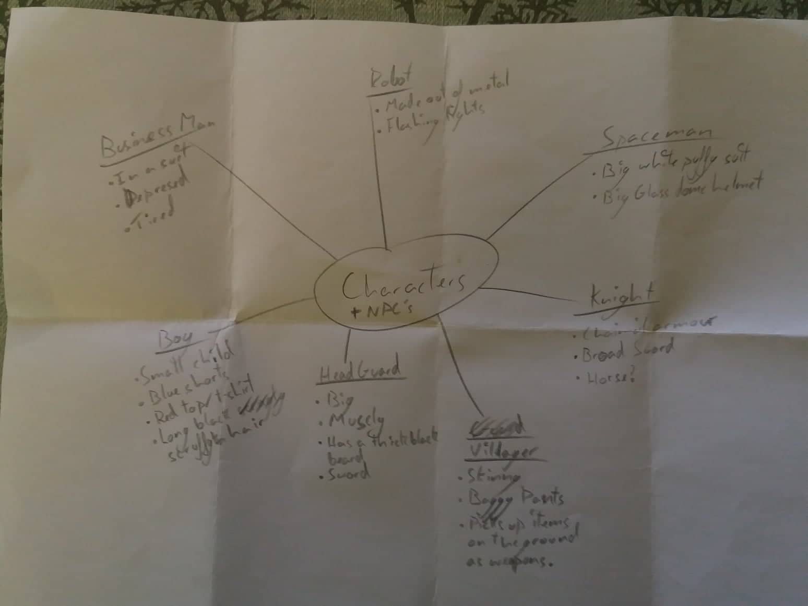

## Feedback

### Game Idea 1

The feedback the player will receive in the space exploration game will be from atmospheric sounds in the background such as “beeps” and “bloops” from the computers as well as sounds from the various pieces of machinery which the player will interact with. The screen will also vibrate from to represent the spaceship getting attacked.

### Game Idea 2

The feedback the player will receive for the football game will be through audio such as the sounds from the ball getting hit and sirens going off when someone scores, the screen will also shake when someone scores. The controller will vibrate when the player receives the ball informing the player that they are in possession and can start running to the goal.

### Game Idea 3

The feedback the player will receive for the platformer game will be through sound, touch and sight. With sound, the player will be able to hear when enemies are close giving the player a chance to avoid them. With touch, the controller will vibrate when the player gets hit or falls from a ledge representing damage. And finally, though sight the player will be able to see the players health bar and read dialogue when speaking with NPC’s.

## Interface

### Game Idea 1

The interface for the space exploration game will have the players health and the ships health in the top left of the screen. In the top right there will be a radar to see if there are incoming ships. The bottom middle portion of the screen will be used for dialogue. That is all the information I will have on the screen as I believe if I had more information on the screen it would block too much of the players vision.

### Game Idea 2

The interface for the football game will be left quite simple similar to how it is presented on television with the score in the top middle of the screen and the two teams playing on the top screen as well. I decided to have the interface this way as now people who watch football on TV will be familiar with the game’s layout.

### Game Idea 3

The interface for the platformer will be left quite simple with the players health and money in the top left corner of the screen. I went with this as I believe it is all the information the player needs to know. I also chose the interface to be quite simple as I know it is achievable with the game engine I will be using.

## Perspectives

### Game Idea 1

The perspective for the space explorer title will be in the first person as I believe it is the most immersive perspective for a game to be in as it feels like you are controlling the character directly. I want this game to be a truly immersive space adventure experience for the player.

### Game Idea 2

The perspective for the football game will be in the top-down perspective so that you will be able to see every character/NPC on the pitch without having to move the camera. I believe this is the right decision as with this perspective the player won’t have to focus on moving the camera all the time and solely put their attention on the game itself.

### Game Idea 3

The perspective for the shanty town platformer will be a 2D side scroller as I believe this is the best perspective for platformer game as proven by other titles such as Celeste and the Mario series. Another reason for choosing this perspective is because the game engine I will be using supports this perspective really well for game development.

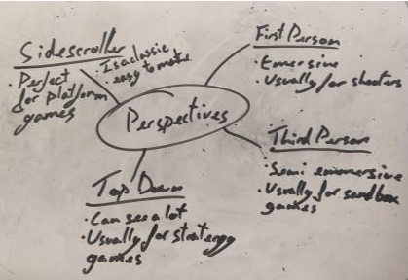

## FMV

### Game Idea 1

the space exploration game will have lots of cut scenes as there will be a loose story. The first cuts cent would be of the character setting off to space in their ship thus starting the game. Another cut scene could be of the character landing back on their planet after completing their mission ending the game.

### Game Idea 2

I haven't thought of any major cuts celeste for this game as I believe it doesn't need any. However, there will be cut scenes for when the player wins and loses a game as I believe that will add more to the game as proven in other sports games cut scenes after a match invigorate the player to keep winning or try and defeat their opponent again. For example, in the mortal Kombat series if you pull off a finishing fatality move it plays an in-game cut scene making you want to keep beating your opponents to get the cuts cent again.

### Game Idea 3

I have thought of many cuts’ scenes for the platformer game as it will be a heavily story driven game. Story based games need cut scenes to provide the player with information crucial to the story in a short space of time. The first cut scene for the game will introduce the player to the main character getting separated from his parents. An interactive cutscene for the game could be that the player is confronted by the head guard who tries to grab him and you have to press a series of buttons to be able to escape. The last cutscene for the game could be when the boy is reunited with his parents.

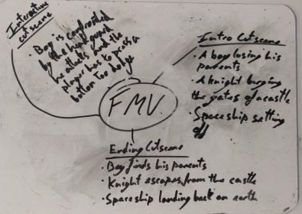

# My Chosen Idea

I have chosen to do idea 3 the shanty town platformer as I believe it will be the most achievable one to make with the game engine I will be using Construct 2. I also feel the most passionate about this idea as I like creating an in-depth story.